Grouping of Elements

* Each Load path is stored in a 1D array (imagine it to be horizontal array) within another vertical 1D array to count for the number of load paths

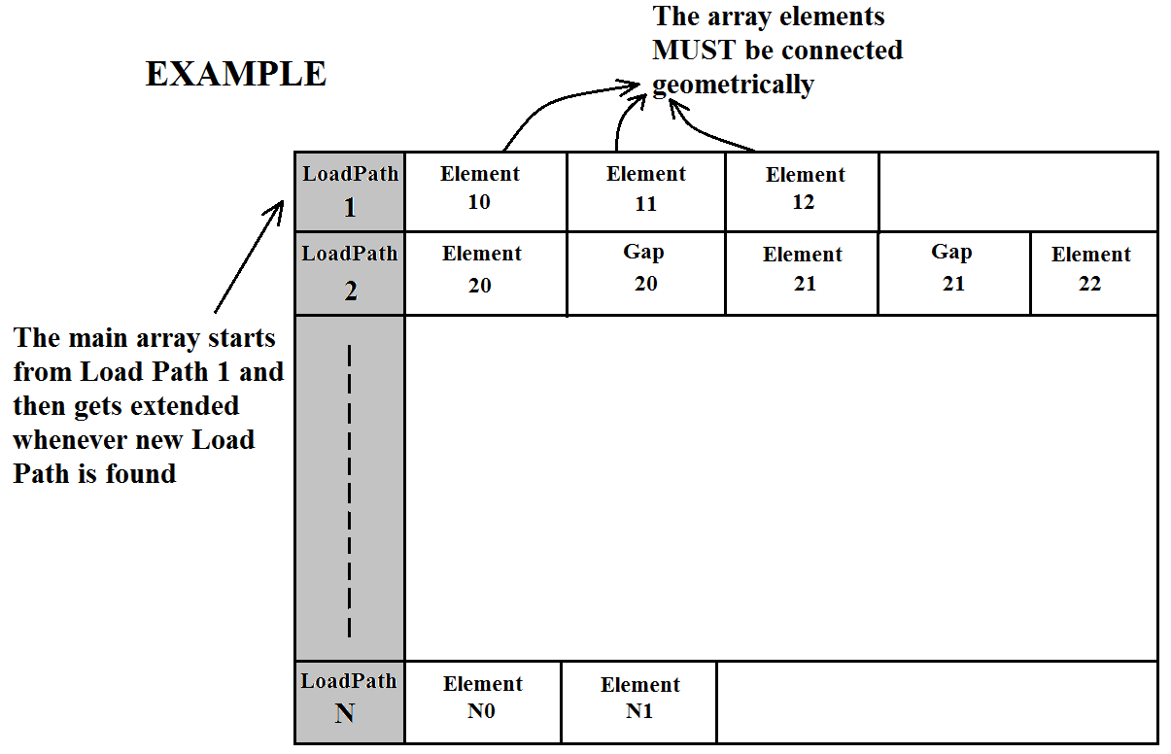

* All inclined (coupling) elements are stored in a single 1D array

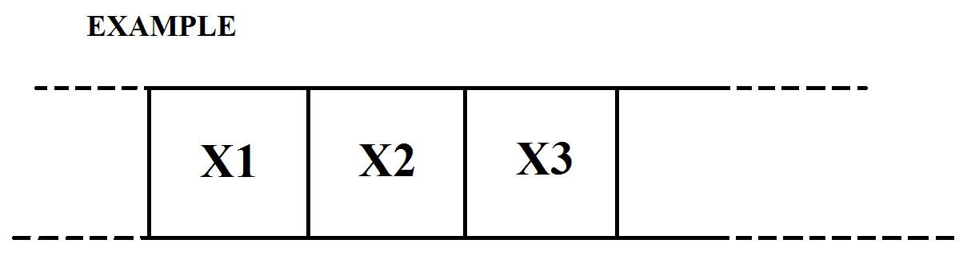

1. Each coupling element can couple different set of two load paths than any of the others
2. Coupling elements should have a notify() finction that implimments the Observer Design Patters (see later)

* Step determination is done as the following:

1. Each load path (horizontal array according the sketch above) gives number of steps equal to the number of its element
2. Required steps are determined by reading each element in the above sketched 2D array and sort "X2" coordinate from the greatest to the least in a 2D array while excluding the repeating "X2" coordinates coming along